* + SCD2 Dimension tests – Repeatable, Content

**DIM_LOCATIONS_SCD - SCD2 Dimension**

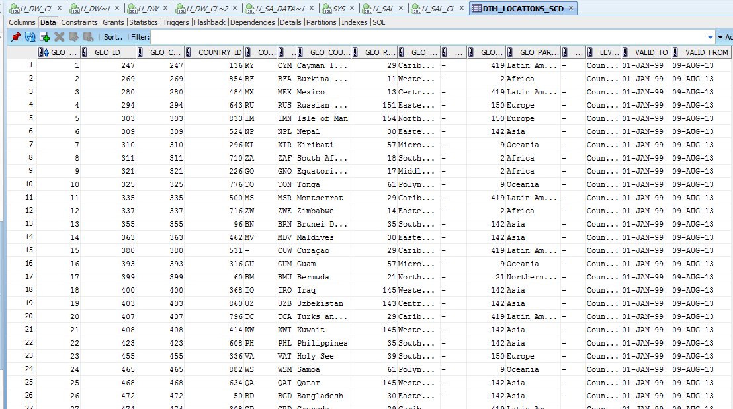

Table is not changed after multiple startup procedure

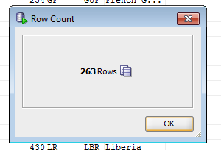

BEGIN

pkg_load_dim_location.load_location;

END;

BEGIN

pkg_load_dim_location.load_location;

END;

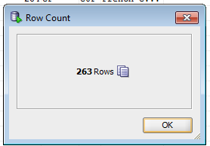

After updating the data in the source table and restart the package data is changed at star-level.

History of changes data is stored in the table:

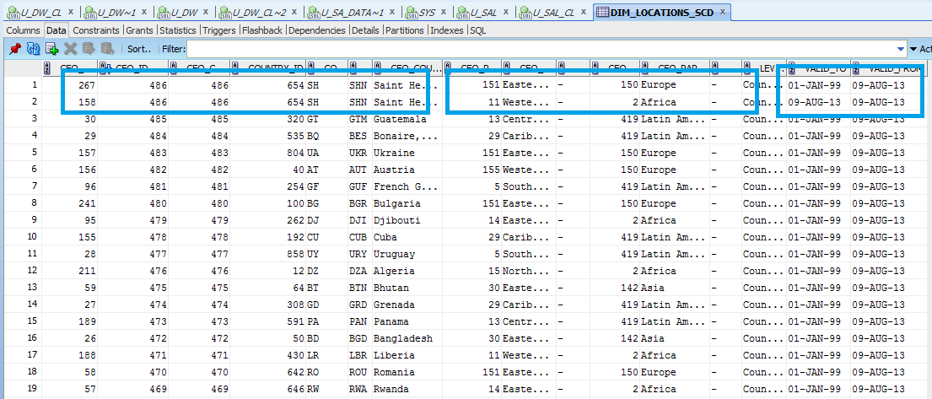

**DIM_CURRENCY_SCD - SCD2 Dimension**

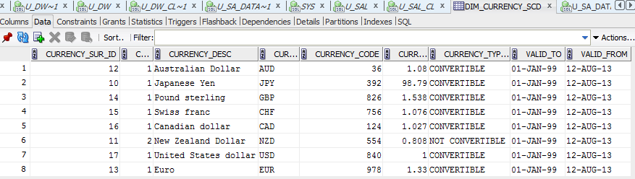

Table is not changed after multiple startup procedure

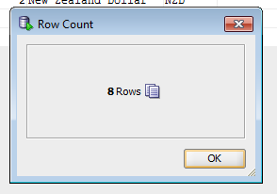

BEGIN

pkg_load_dim_currency_sal.load_currency;

END;

BEGIN

pkg_load_dim_currency_sal.load_currency;

END;

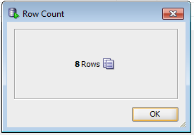

After updating the data in the source table and restart the package data is changed at star-level.

History of changes data is stored in the table:

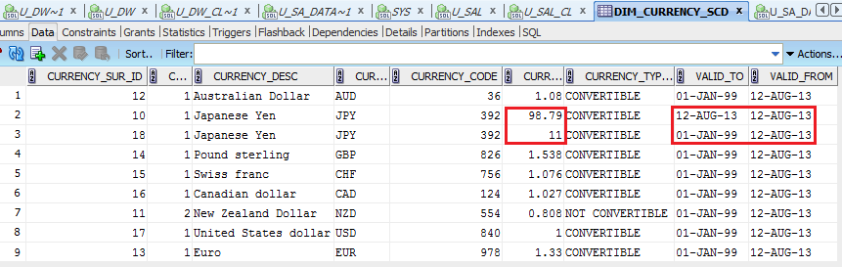

* + Common Dimension

DIM_CUSTOMERS

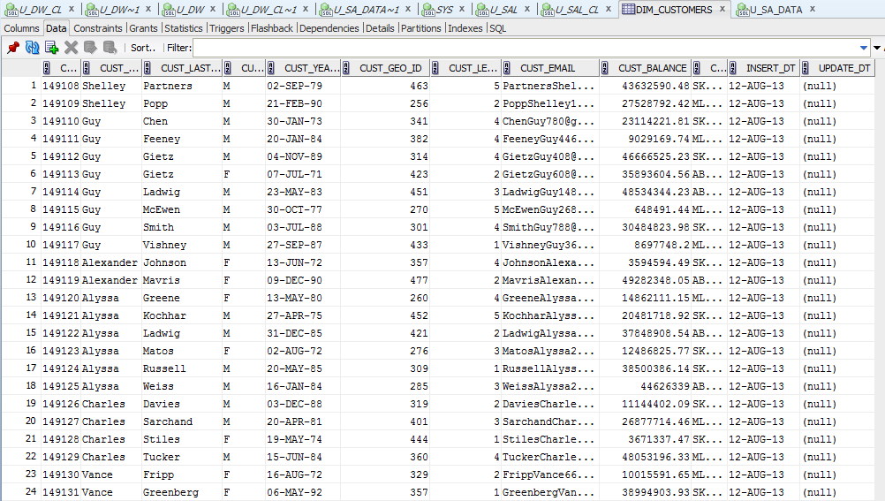

DIM_OPERATIONS

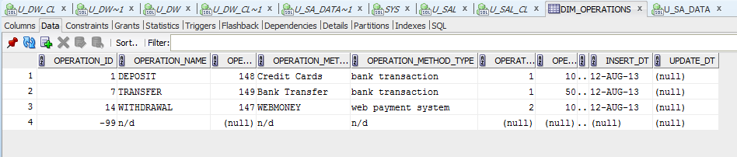

DIM_TARIFFS

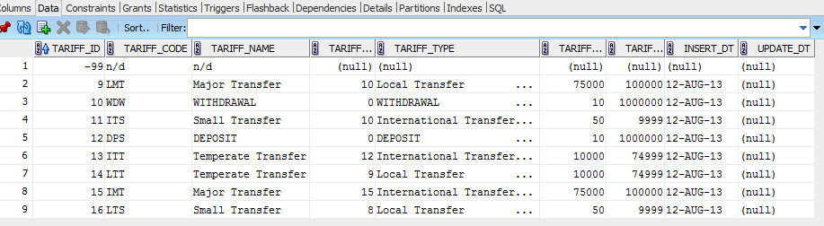

DIM_TIMES_DAILY

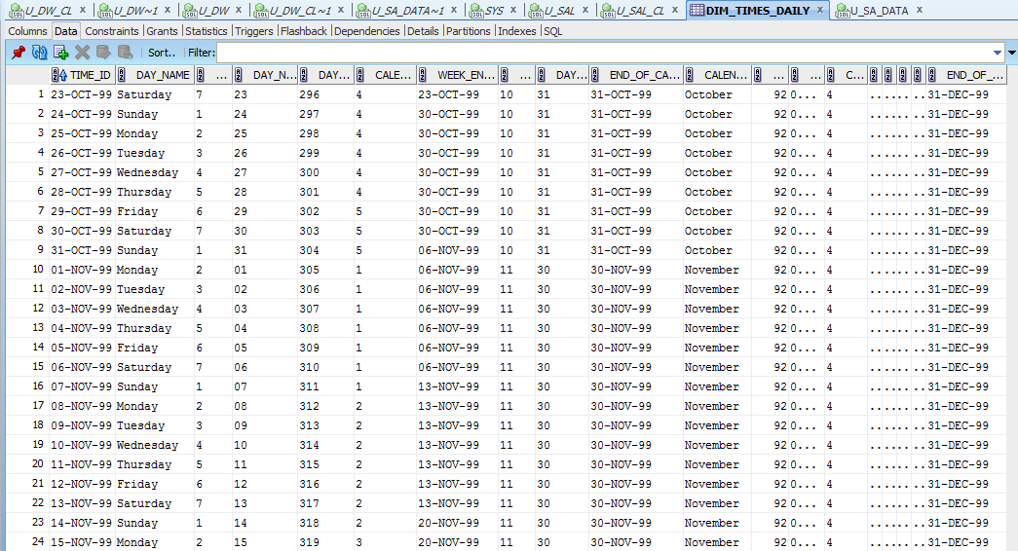

DIM_GEN_PERIODS

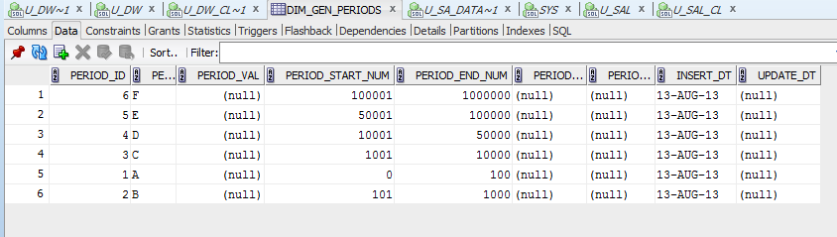

* + Fact Table

FCT_TRANSACTION_DAILY

